##### With Joint Collaboration

##### Government Arts and Science College Karwar & NSS Units 1& 2 ,

##### Nehru Yuva Kendra Sangathan Karwar and Kadalasiri Youth Club Karwar

##### **REPORT OF IYDC 2022**

Summited To : Government Arts and Science College, Karwar

Summited By : Kadalsiri Youth Club Karwar

### **About the program of**

### **international yoga day celebration 2022( IYDC2022)**

India has made a wonderful contribution to the world called Yoga. Yoga is not confined to India, but the entire world celebrates the importance of yoga by celebrating the World Yoga Day on June 21.In the same vein, on June 21, the NSS Units of the Government Arts and Science College Karwar organized a yoga abhyas program with joint collaboration Nehru Yuva Kendra and Kadalasiri Youth Club Karwar.Shri Kamalakar Kamble arrived as resource person for the event and taught the students the importance of yoga, the dimensions and the practice of yoga. 43 students participated in the program and a certificate was issued to the students who participated.The program was chaired by Prof. Vidya Nayak Principalof the college, Shri Yashwant Yadav District Officer of the Nehru Yuva Kendra , Professor Geeta Wallikar, Senior Professor and College Welfare Officer, Vijayashree Gaokar, NSS Unit 1 Program Officer, NSS Unit 2 Program OfficerLokesh N P, ATC of NYKS Meera Naik and Prakash Bhovi, president of Kadalsiri Youth Club all this all honorable present in the program. the program end with the Refreshment distribution among the participates .

* Number of Total participants : 43
* Duration Section : 40 minutes
* Number of Covered asanas : 13

### **INVITATION of IYDC2022**

#### stage program of IYDC2022

#### brief note by the Resource person on yoga

#### The Picture Of Yoga Abhyas

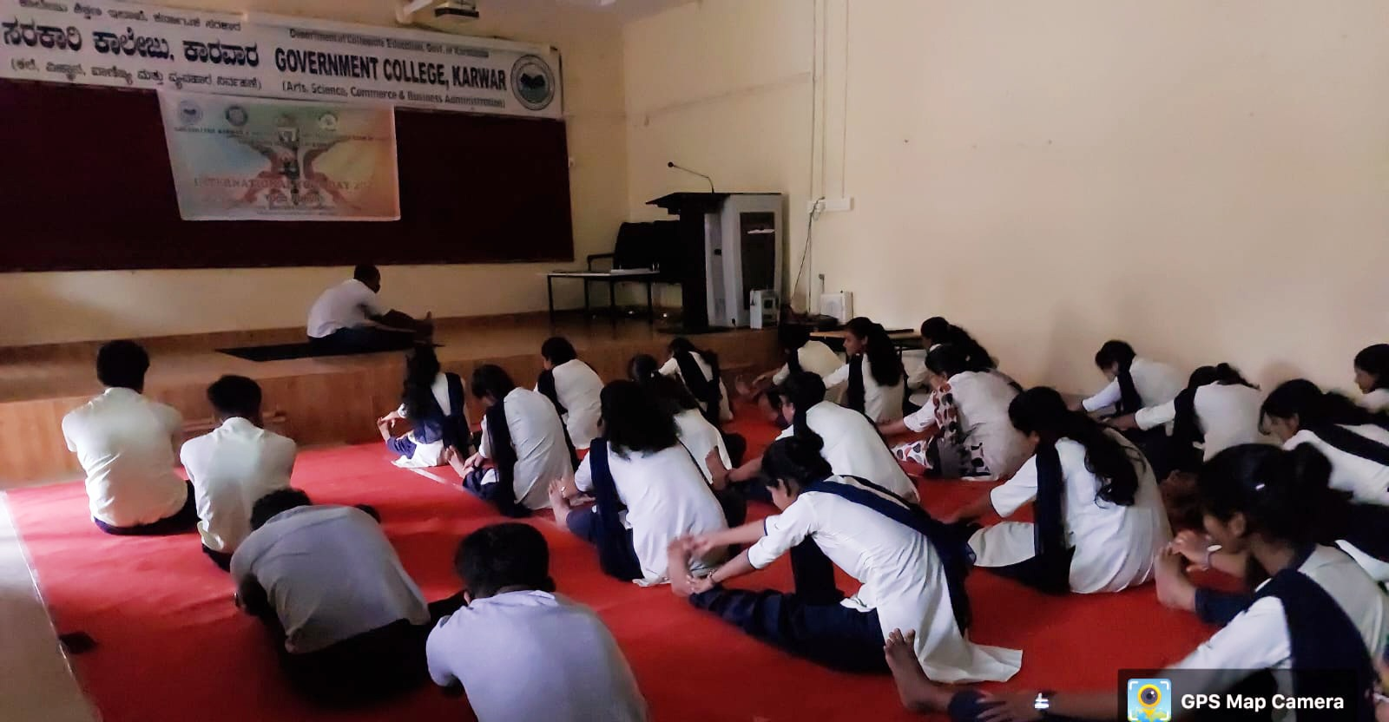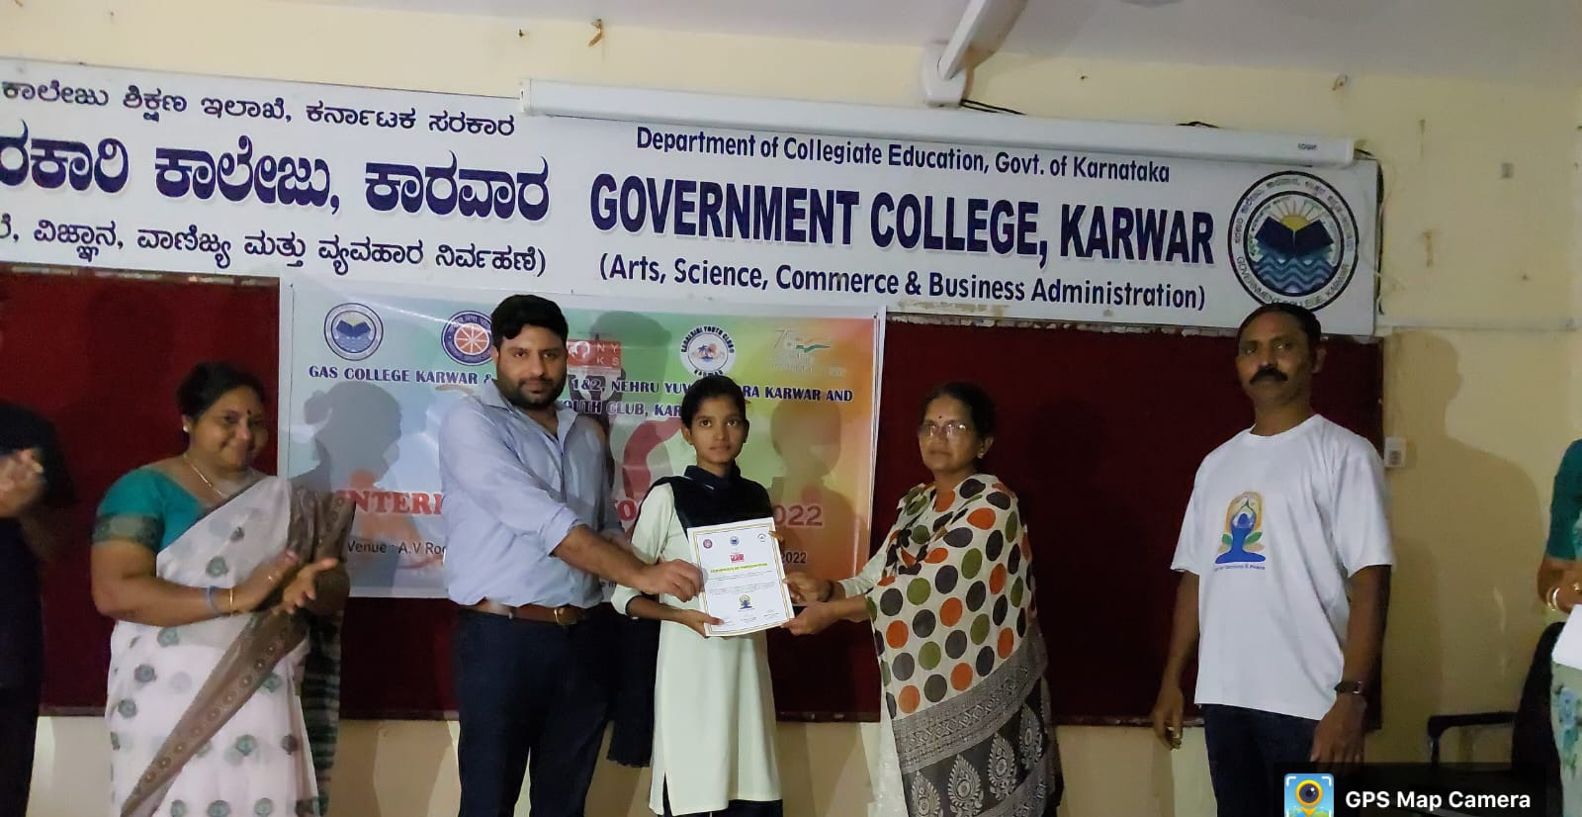

#### Participation certificate distribution

#### The presence of Honorables

### **the model of participation certificate**

#### 

### **the list of presence of honorables**

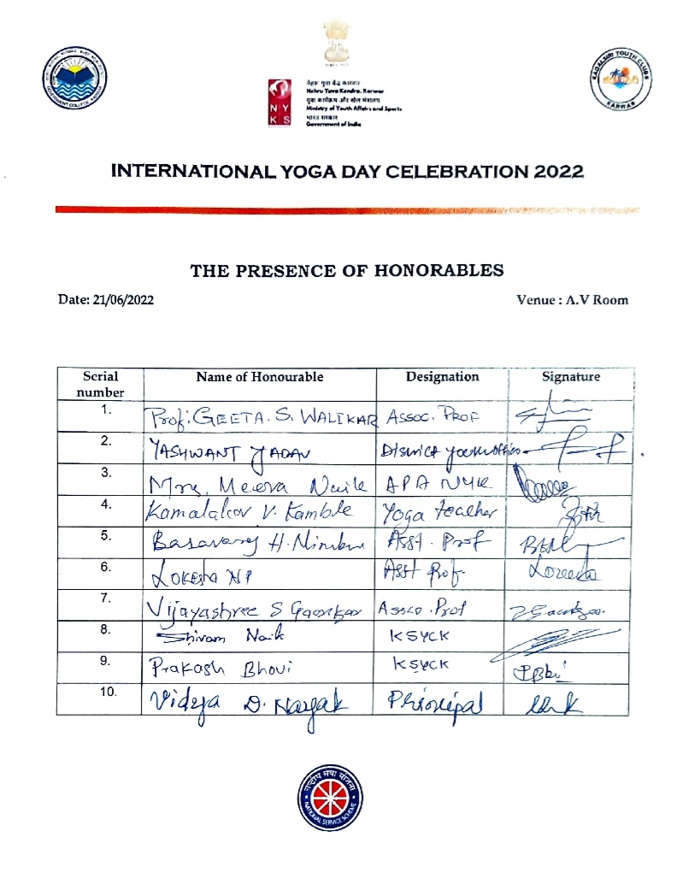

### **participation list of IYDC 2022**

